USER STORIES:

WHAT is user story?

an informal, general explanation of a s/w feature written from the perspective of the end user.

--key component of agile s/w development is putting people first

--after reading user story, team should be aware of what they're building.

--one of the core component, it help user-focused for daily work.

---user story is smallest unit of work in agile

--purpose of user story is to how piece of work will deliver value back to customer

stories fit into agile frameworks like SCRUM and KANBAN

SCRUM: user stories r added to sprint-->estimation and sprint plan

KANBAN: team pulls Us & run them through workflows--->work in progress

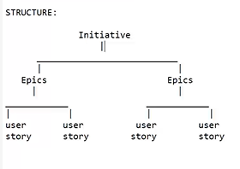

*WHY we create user stories?

focus on the user

enable collaboration

creative solutions

create momentum

Good user stories: (3 C’s)

Card: Written description of the story, used for planning and as a reminder

Conversation: Conversations about the story that serve to flesh out the details of the story

Confirmation: Tests that convey and document details that can be used to determine when a story is complete.

*USER STORY FORMAT:

As a < user > =>WHO

I want to < perform an action > =>WHAT

So that < I expect…. > =>WHY

Examples:

1)As a registered user, I want to easily log in to my account

so that I can access personalized features and manage my account information securely.

2) As a traveller, I want to easily find and book local experiences

so that I can immerse myself in the culture of the places I visit and create lasting memories.

3) As a customer, I want to track my order, so I can know when to expect delivery.

*INVEST in user stories:

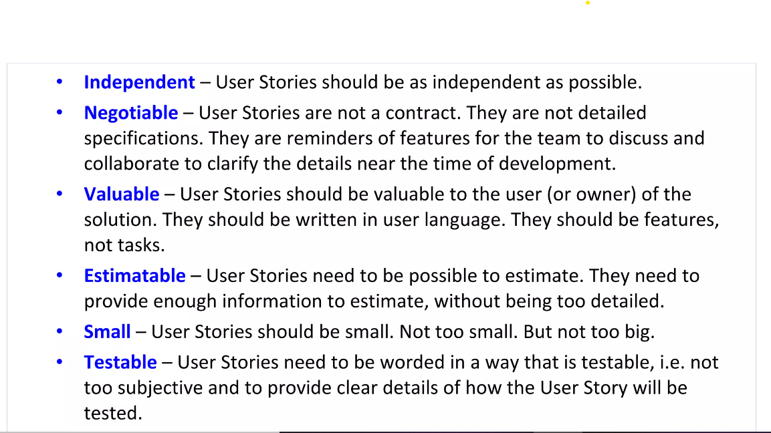

ACCEPTANCE CRITERIA:

Acceptance criteria (AC) are the conditions a software product must meet to be accepted by a user, a customer, or other systems. They are unique for each user story and define the feature behavior from the end-user’s perspective.

Good acceptance criteria should possess specific qualities:-

Clarity: They should be straightforward and easy to understand for all team members, avoiding any confusion.

Conciseness: The criteria should communicate the necessary information without unnecessary detail.

Testability: Each criterion must be verifiable, allowing testers to clearly determine whether it has been met.

Result-oriented: The focus should be on delivering results that gratify the customer, emphasizing the end benefit or value.

epic-level requirement

______|_________

| |

user story1 user story2

| |

_______________ ____________

| | | |

ac(1) ac(2) ac(1) ac(2)

Acceptance criteria FORMAT:(GWT acceptance criteria template)

1)scenario-oriented

Given -some precondition

When- do some action

Then - expect some result

The acceptance criteria, follow a template with five main statements:

Scenario - the name for the behavior that will be described

Given - the beginning state of the scenario

When - specific action that the user makes

Then - the outcome of the action in “When”

And - used to continue any of three previous statements

EXAMPLES:

Title: User Login

User story: As a registered user ,I want to be able to log in to my account ,So that I can access personalized features and information on the platform.

Scenario 1: Successful Login

Given I am on the login page

When I enter my valid username and password

And click the "Login" button

Then I should be redirected to the dashboard

And see a welcome message confirming my successful login

And have access to my personalized account features.

Scenario 2: Incorrect Password

Given I am on the login page

When I enter my valid username

And enter an incorrect password

And click the "Login" button

Then I should see an error message indicating that the password is incorrect

And the system should not log me in.

Scenario 3: Non-existent User

Given I am on the login page

When I enter a non-existent username

And enter a valid password

And click the "Login" button

Then I should see an error message indicating that the user does not exist

And the system should not log me in.

Scenario 4: Empty Fields

Given I am on the login page

When I leave both username and password fields empty

And click the "Login" button

Then I should see error messages indicating that both fields are required

And the system should not log me in.

Scenario 5: Forgot Password

Given I am on the login page

When I click on the "Forgot Password" link

Then I should be redirected to the password recovery page

And be prompted to enter my email to reset the password.

**Epics:**

An agile epic is a body of work that can be broken down into specific tasks (called user stories) based on the needs/requests of customers or end-users.

Epics are a helpful way to organize your work and to create hierarchy.

The idea is to break work down into shippable pieces so that large projects can actually get done and you can continue to ship value to

your customers on a regular basis.

Epics help teams break their work down, while continuing to work towards a bigger goal.

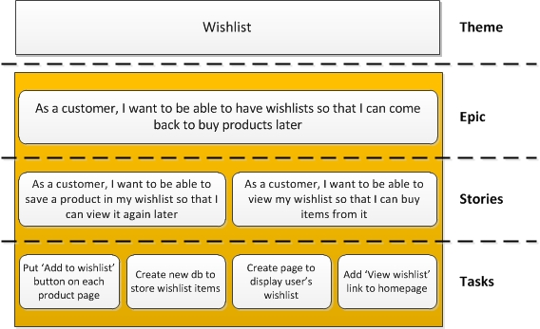

USER STORIES FOR HOTEL MANAGEMENT SYSTEM

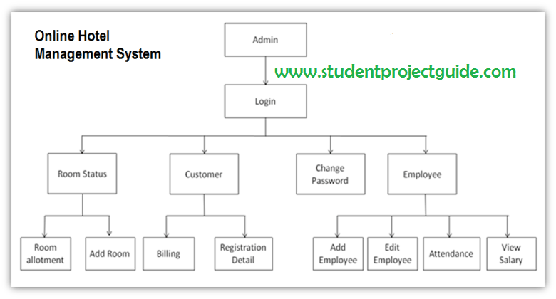

ADMIN

USER story1

As an admin, I want to be able to log in hotel management system.

So that I can access and manage the system’s admin functionalities

User story2

As an admin, I want to manage user roles & permissions,

So that I can control access levels for different staff members

User story3:

As a admin, I want to monitor and manage reservations

So that I can see the hotel booking activities and address any issue that may rise

for login

User story1 :Guest login

As a hotel guest, I want to log in to the hotel management system, so that I can access information about reservation and personalize my stay

User story2: Staff login

As a staff member, I want to log in to hotel with my credentials, so that I can access administrative tools and manage reservations

User story3 :Admin login

As a system administrator, I want to log in to the hotel, so that I can configure system settings and manage user roles.

ROOM ALLOTMENT:

User story 1:

As an admin , I want access to overview of all room allotments,

So that I can monitor the current occupancy status

User story2:

As a front desk, I want to easily assign rooms to guests

So that I can provide smooth and efficient experience for guest arriving

User story3:

As a hotel manger, I want to generate reports for room allotments

So that I can access the performance of the room allocation

ADD ROOM:

User story1:

As an admin, I want to add new room, So that hotel inventory can updated with latest accommodations.

Userstory2:

As a front desk, I want to specify room types available in the hotel,

So that guests can choose from variety of accommodations

User story3:

As a customer, I want to know rooms are accessible for pet-friendly, so that I can enjoy the comfort with pets.

BILLING:

User story1:

As a admin, I want review and analyze billing data , so that I can make informed decisions about pricing, promotions.

User story2:

As a front desk, I want apply discounts or promotions to a guest’s bill

So that guest can enjoy special offers and can attract hotels.

User story3:

As a customer, I want to receive a detailed & transparent bill at checkout,

So that I can review & understand the charges for my stay.

REGISTRATION DETAIL:

User story1:

AS a front desk staff, I want to efficiently register a new guest,

So that they can easily access their room and services.

User story2:

As a Admin,I want to customize the registration form based on specific requirements,

So that we can collect relevant information for various types of guests or events.

User story3:

As a Hotel Customer, I want to complete an online pre-registration before arriving at the hotel,

So that check-in is speed up upon my arrival.

ADD EMPLOYEE:

User Story 1:

As a admin ,I want to add a new employee to the hotel management system,

So that the staff register is up-to-date and roles are properly assigned.

User story2:

As a Hotel Front Desk Staff, I want to easily add new staff members to my team,

So that we can collaborate effectively and ensure smooth operations.

User story3:

As a Hotel Customer, I want assurance that hotel staff accessing my information are authorized,

So that my personal details are handled securely.

EDIT EMPLOYEE:

User Story 1:

As a Hotel Admin, I want to edit the details of an existing employee,

So that the system reflects accurate and up-to-date information.

User story2:

As a Front Desk Staff, I want to request changes to my job role or permissions,

So that I have the necessary access to perform my duties.

User story3:

As a Hotel Admin, I want to change an employee's login credentials,

So that the security of the system is maintained.

ATTENDENCE:

User Story 1:

As a Hotel Admin, I want to set up a system for automated attendance tracking,

So that manual entries are minimized, and accuracy is improved.

User story2:

As a Front Desk Staff, I want to request leave or mark days off in the attendance system,

So that the hotel can plan for staff availability accordingly.

User story3:

As a Hotel Customer, I want to provide feedback on the stay and availability of hotel staff,

So that the hotel can address any issues related to staff attendance.

VIEW SALARY:

User story1:

As a Hotel Admin, I want to view the salary details of all employees,

So that I can ensure accurate payroll processing and financial management.

User story2:

As a Hotel Admin, I want to view historical salary data for employees,

So that I can track changes, adjustments, and promotions over time.

User story3:

As a Hotel Front Desk Staff, I want to view my own salary details,

So that I can keep track of my earnings and understand the components of my salary.